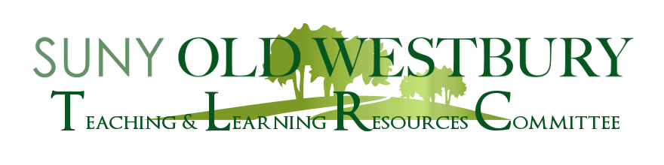

**Open Dialogue**

**Classroom Observation as a Positive Learning Experience**

A Workshop Led By

**Dr. Maureen Keefe, School of Professional Studies**

**Thursday, March 31, 2022 2:40 – 3:40pm Virtual (Zoom)**

To implement continuous improvement of our pedagogy, programs request faculty to conduct certain classroom observations. Relevant factors to consider in evaluating and reporting faculty teaching effectiveness will be discussed.

*\*Please bring a copy of your department’s classroom observation form\**

Zoom Registration:  <https://suny-ow-edu.zoom.us/meeting/register/tZ0ocO-oqzotHd0CdOl_3spqrqnblKQ6cHMI>